**REGISTRATION**

At first **Register** yourself by going to the URL **(**<https://tathyasathi.bangla.gov.in/>)

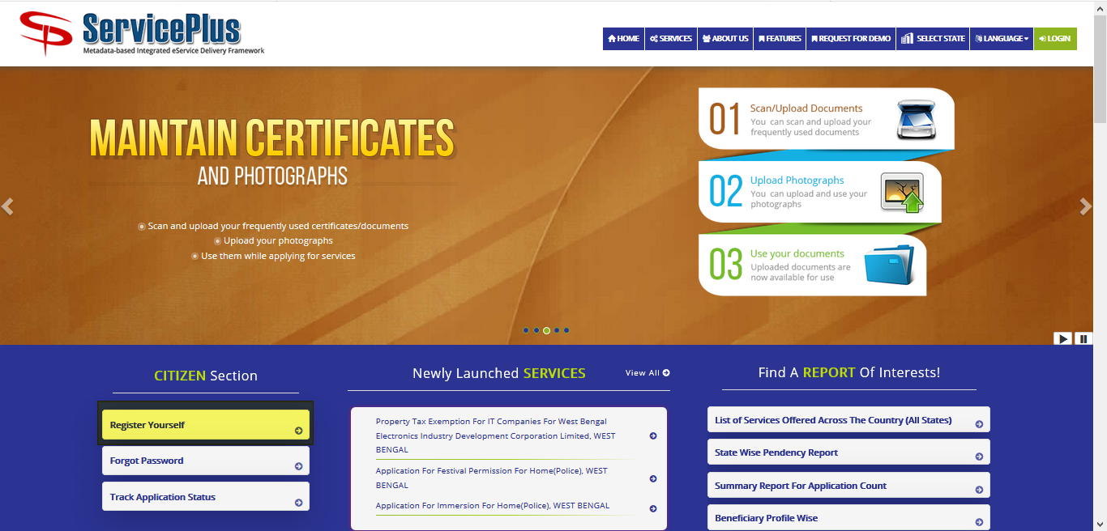

Fill in with proper **details** and **validate**.

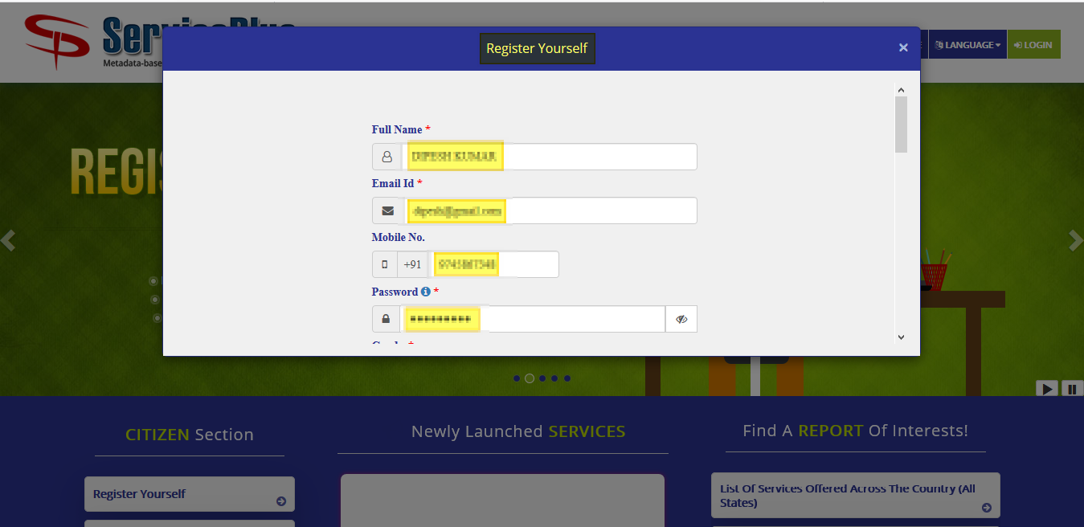

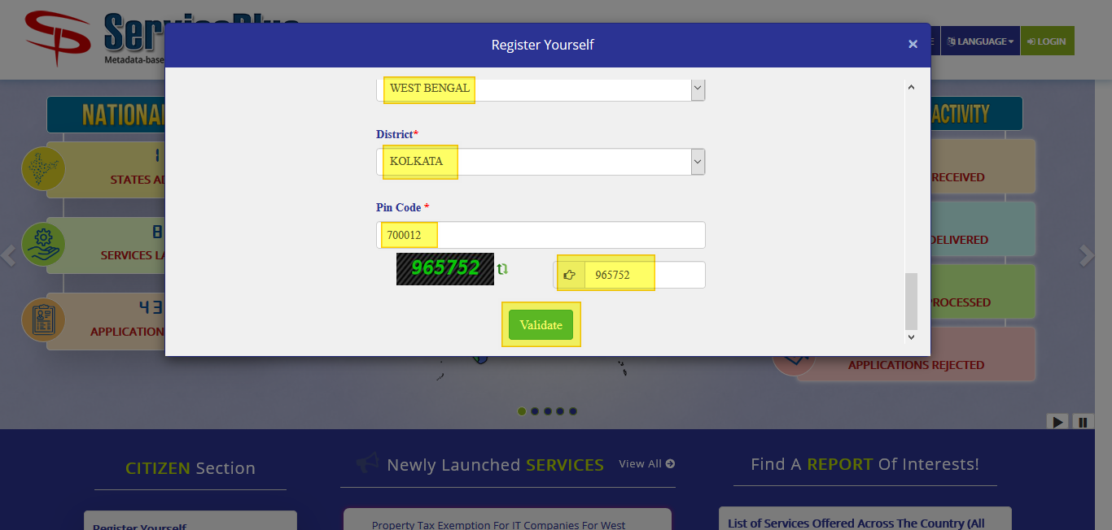

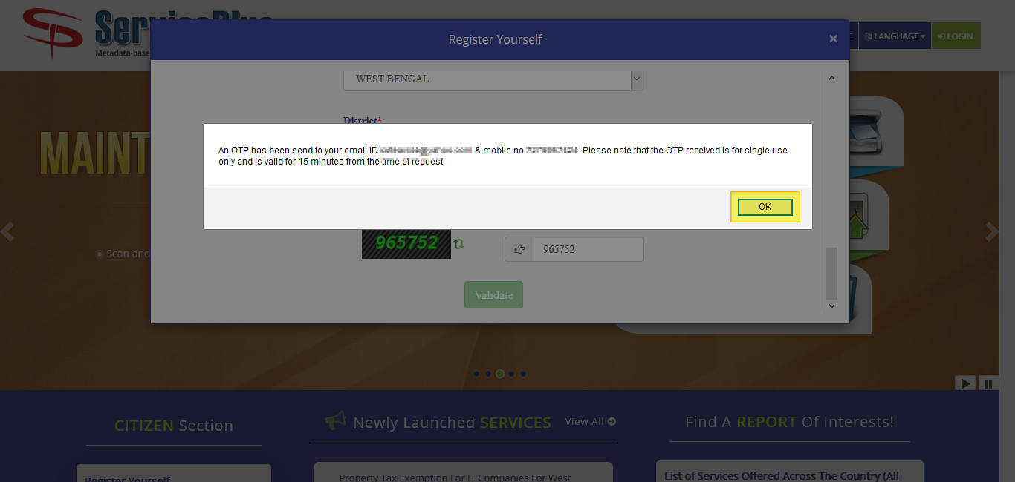

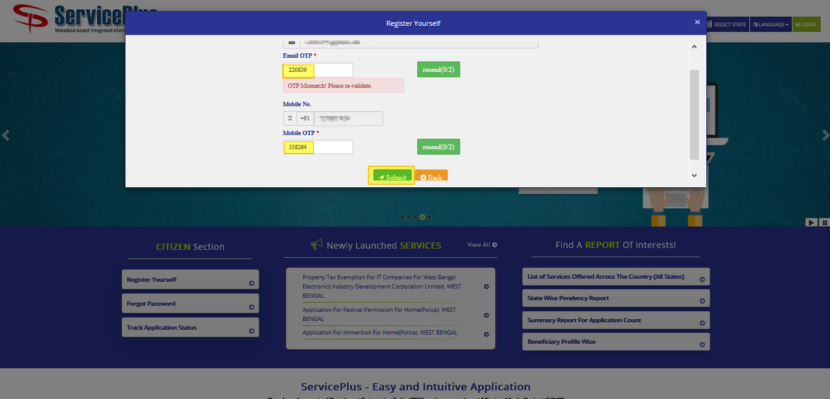

After successful registration.

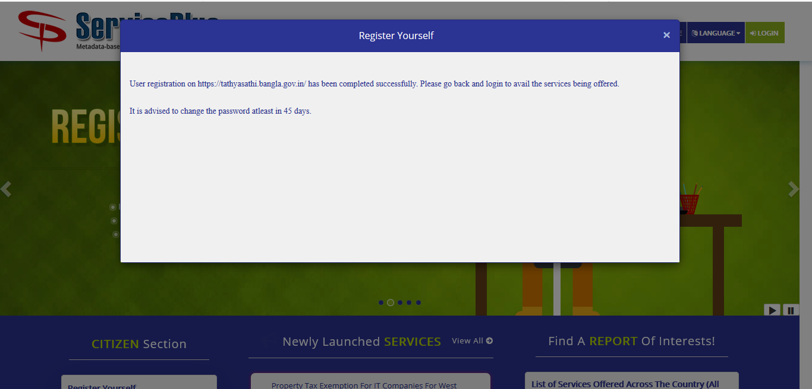

**APPLICATION PROCESS**

**STEP -1:**

At first login to Service plus web portal**: (**<https://tathyasathi.bangla.gov.in/>) to apply for the **Application for Maintenance of Flats in Bidhannagar Municipal Corporation Area**.

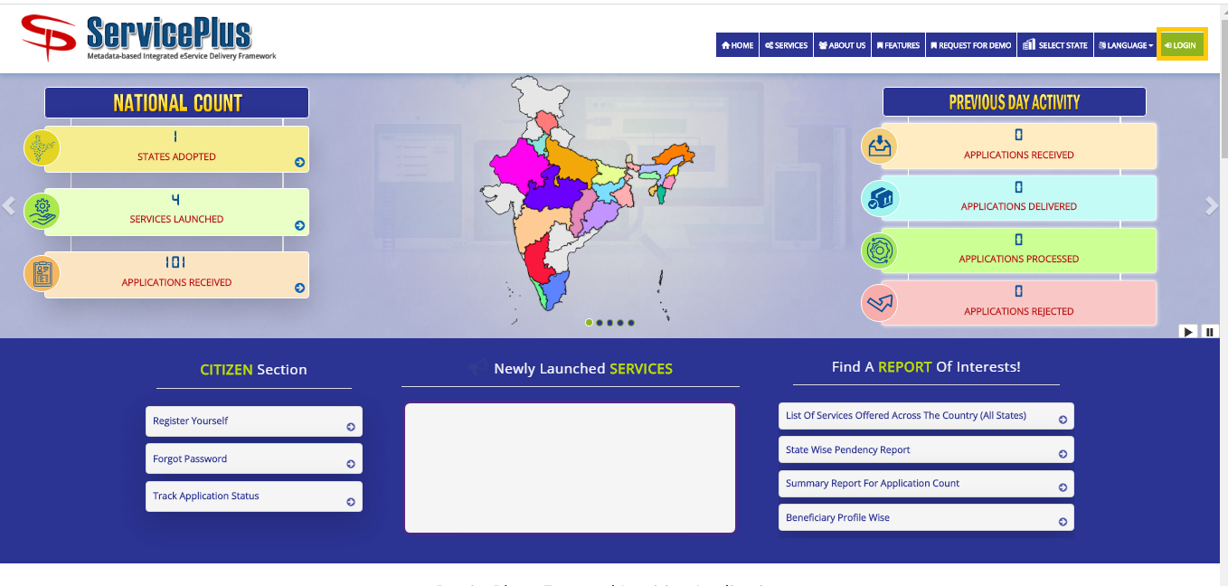

**Step -2:**

Login in the Service plus portal.

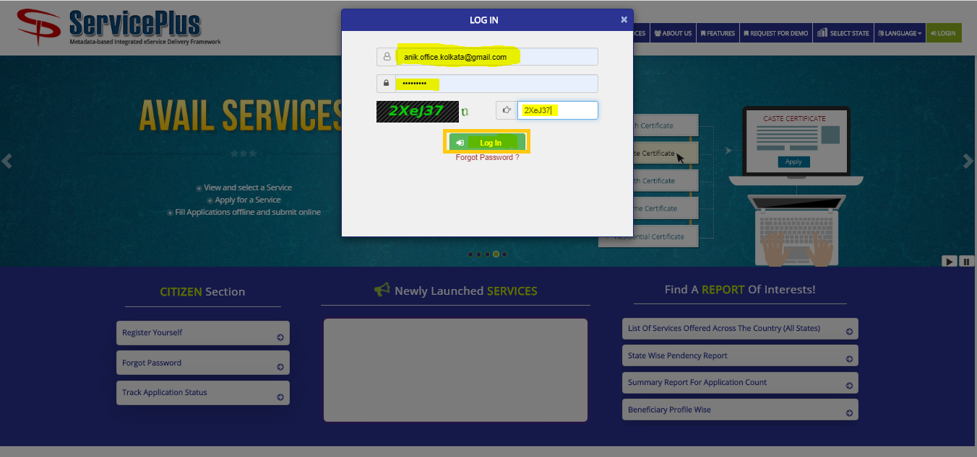

**Step -3:**

Now click “**Apply for services”** and select “**View all available services**”, then Select particular Service and Fill the form:

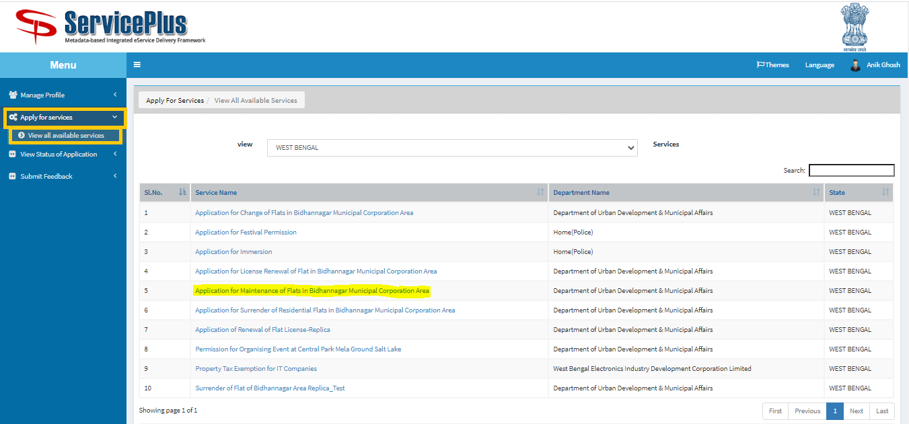

**Step -4:**

Fill the details “**Flat No**” and “**License Number**” and click **Get Data.**

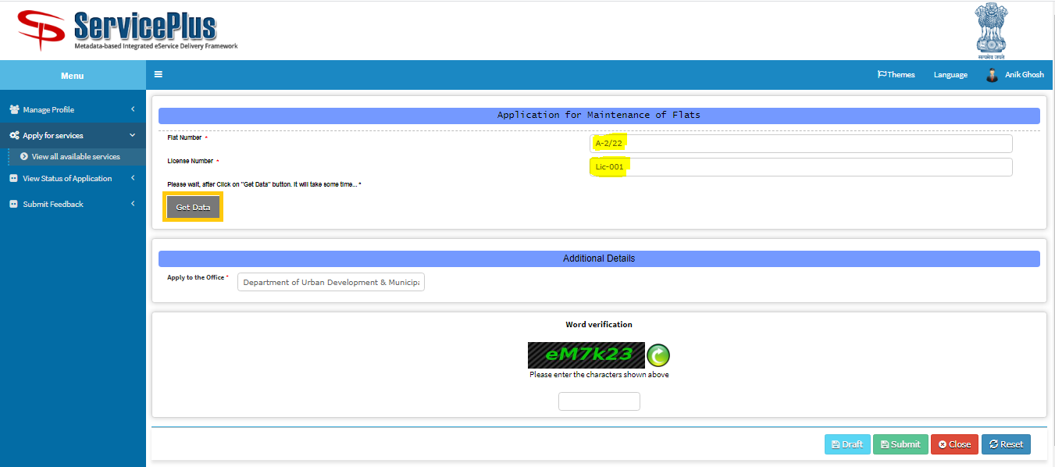

**Step -5:**

Fill the form with the details as required.

After that submit by matching the captcha.

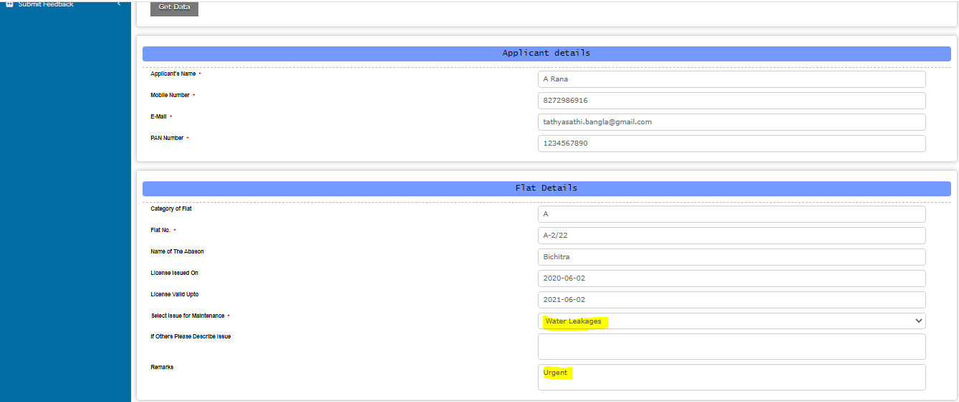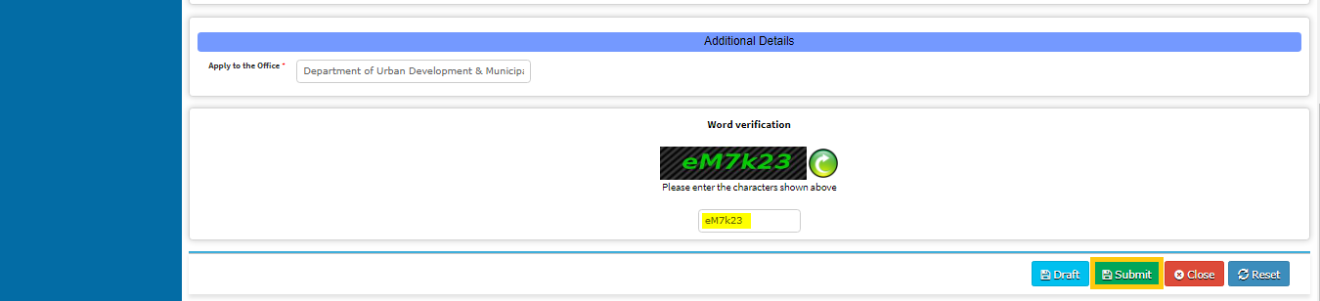

View the entered Data

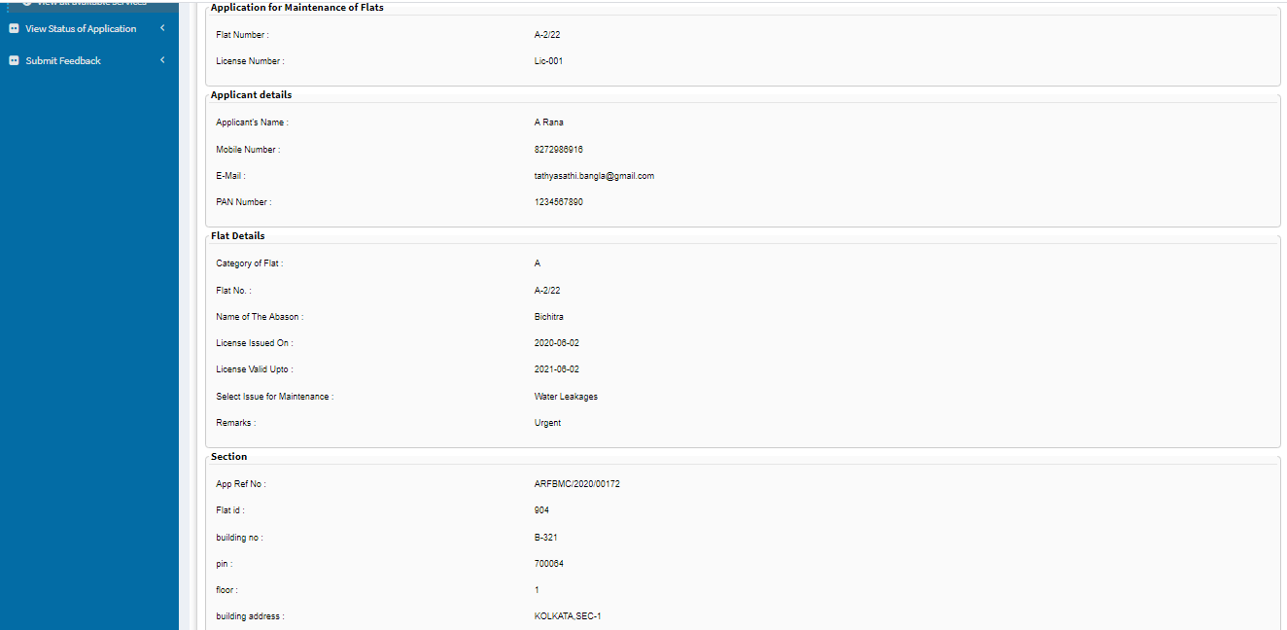

**Step -6:**

Now click “**Attach Annexure**” to attach your provided document.

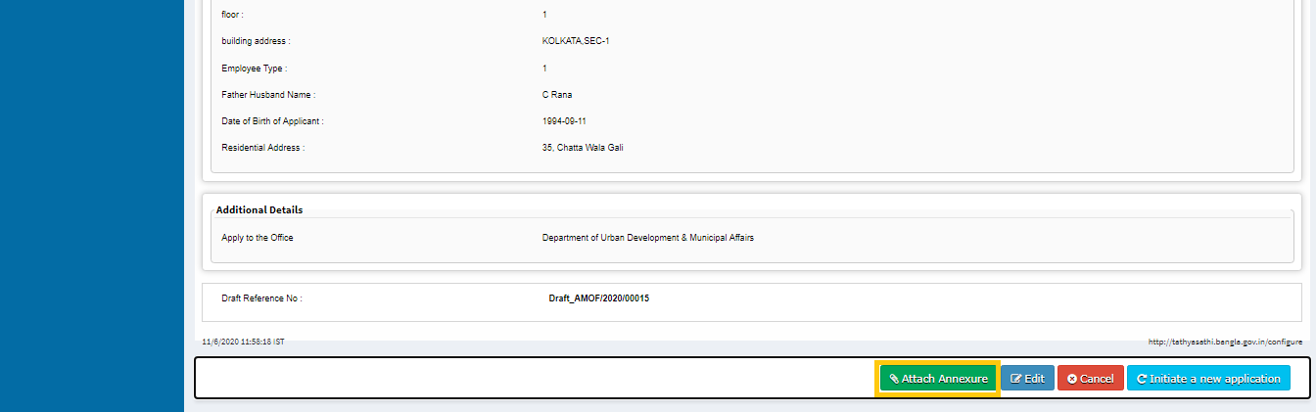

**Step -7:**

Now select the appropriate annexure and click on “**save annexure”**.

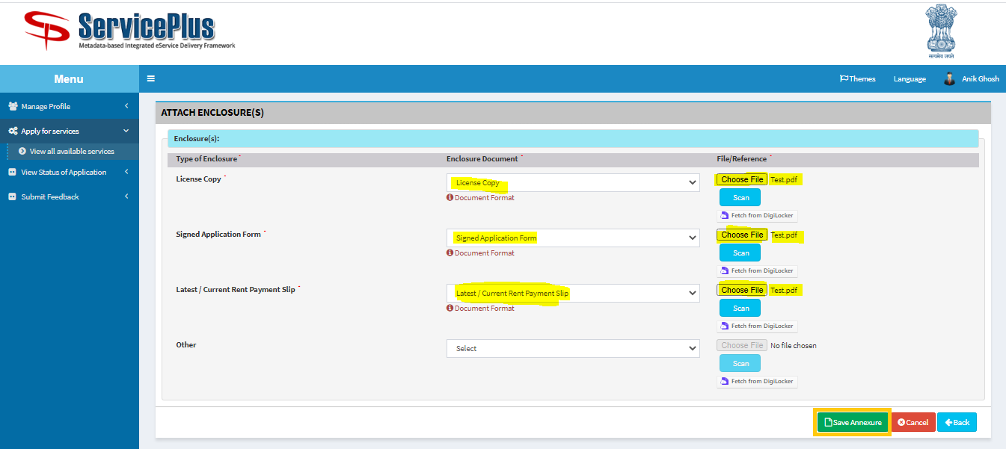

**Step -8:**

Now go through the form and click **submit** for applying.

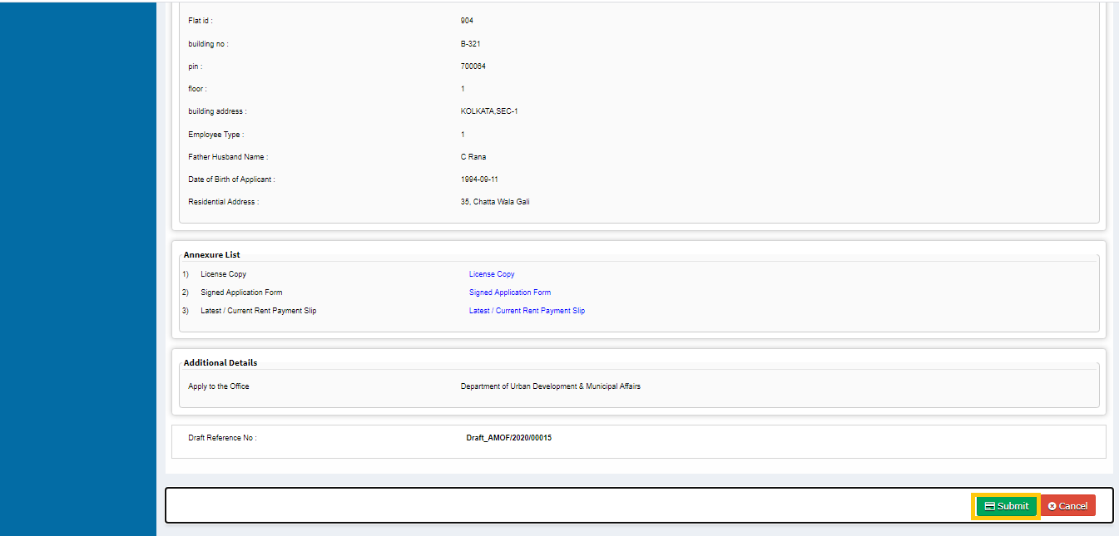

**Step -9:**

After Submission of form an acknowledgement slip is generated with **app reference number.**

Save by selecting “**Export to pdf”** or print it by selecting “**Print”**

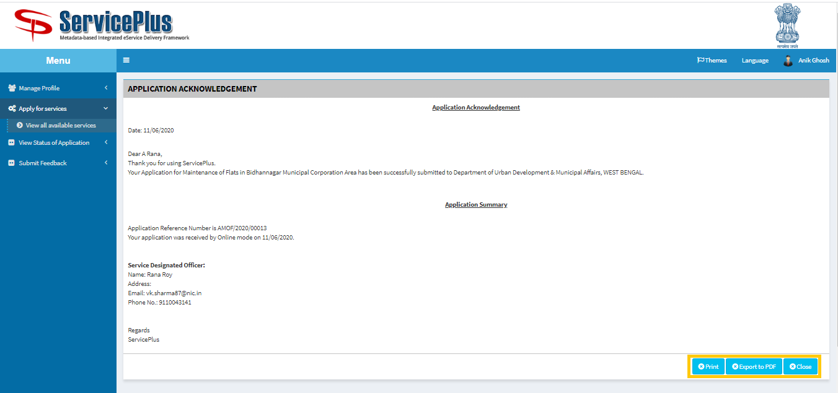

**FEEDBACK BY APPLICANT**

**Step -1:**

To Track the application we can select “**View Status of Application”** and go to “**Track application status”.**

Here select the appropriate date from to when and it’s optional to give “**app ref no”** to “**get data”.**

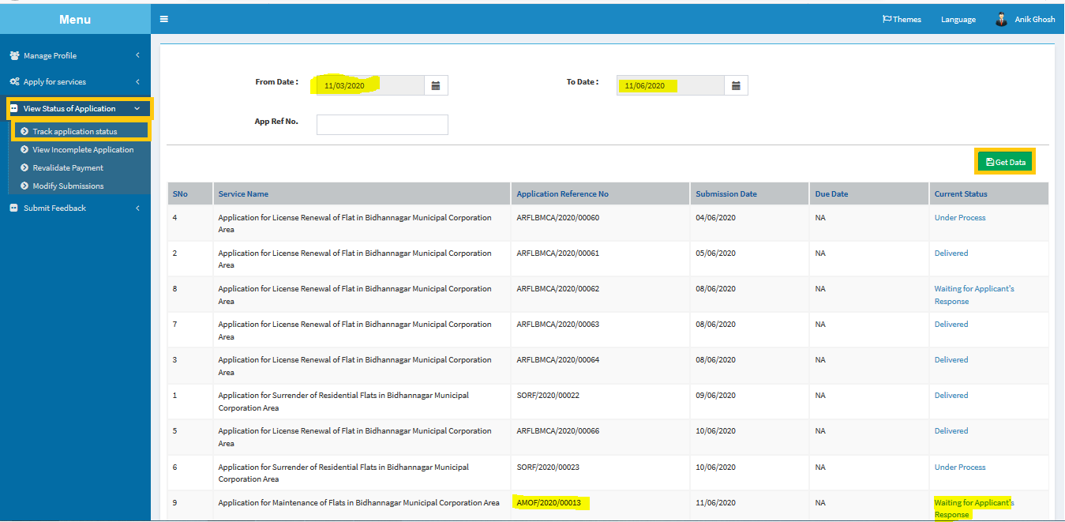

**Step -2:**

Select **click here** to re attach your attachment.

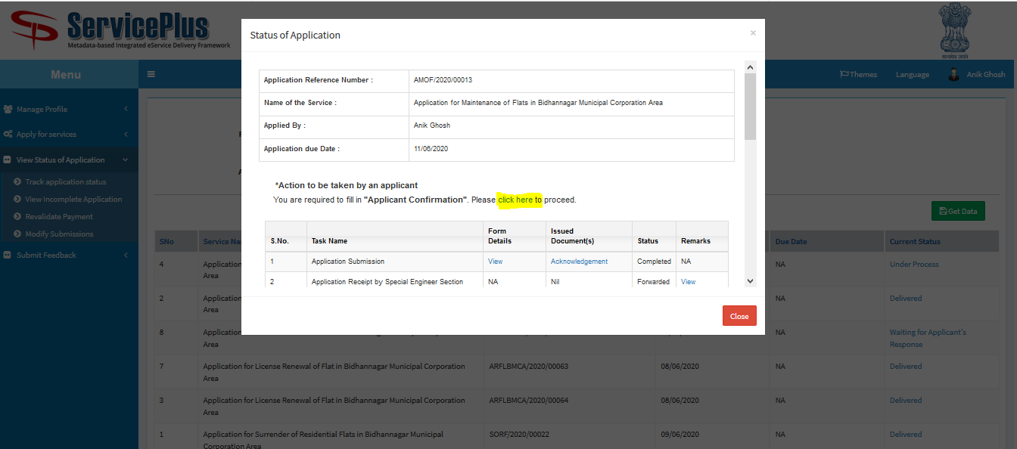

**Step -3:**

Fill “**Remarks**” & “**Yes/No Issue Resolved**” then click on “**Submit**” Button

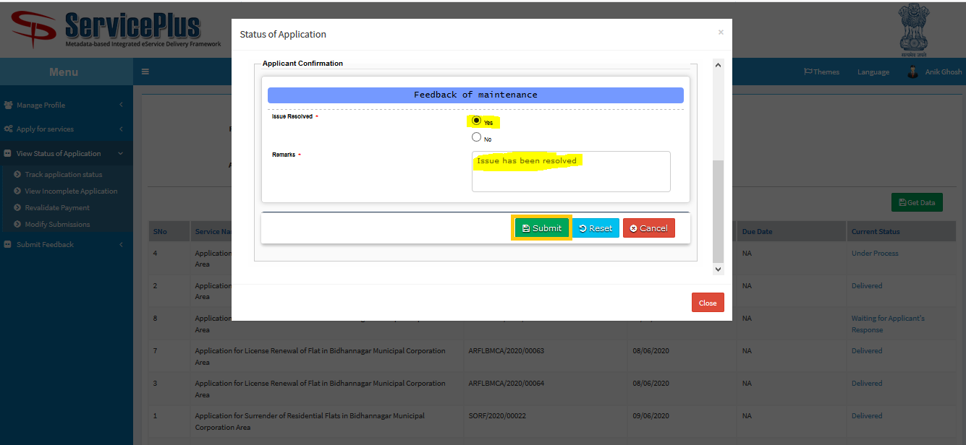

After Successful Submission this Message will be shown.

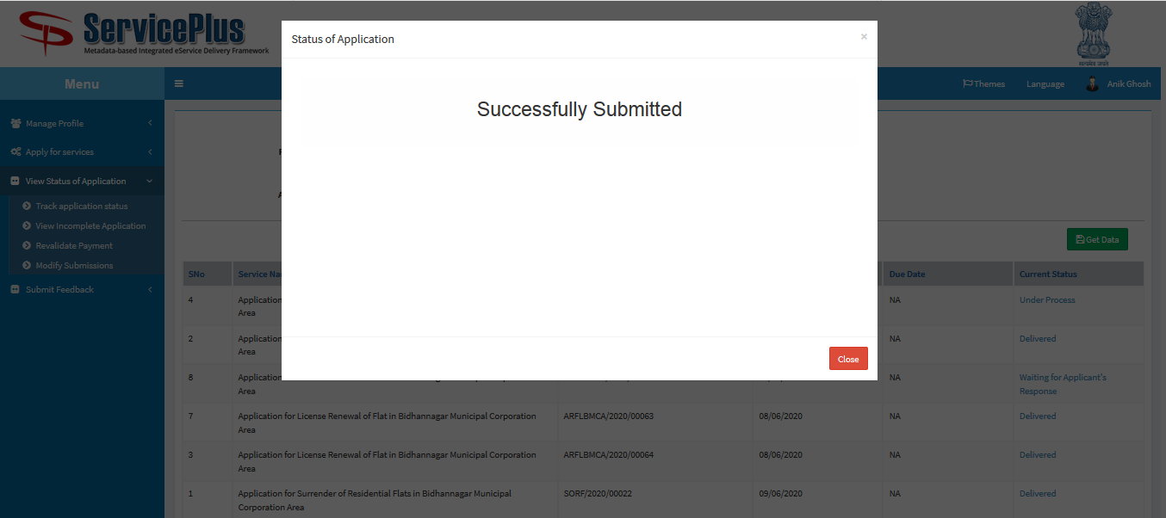

**SHORTFALL CASE**

**Step -1:**

To Track the application we can select “**View Status of Application”** and go to “**Track application status”.**

Here select the appropriate date from to when and it’s optional to give “**app ref no”** to “**get data”.**

Select “**Waiting for Applicant’s Request”**.

A popup will open.

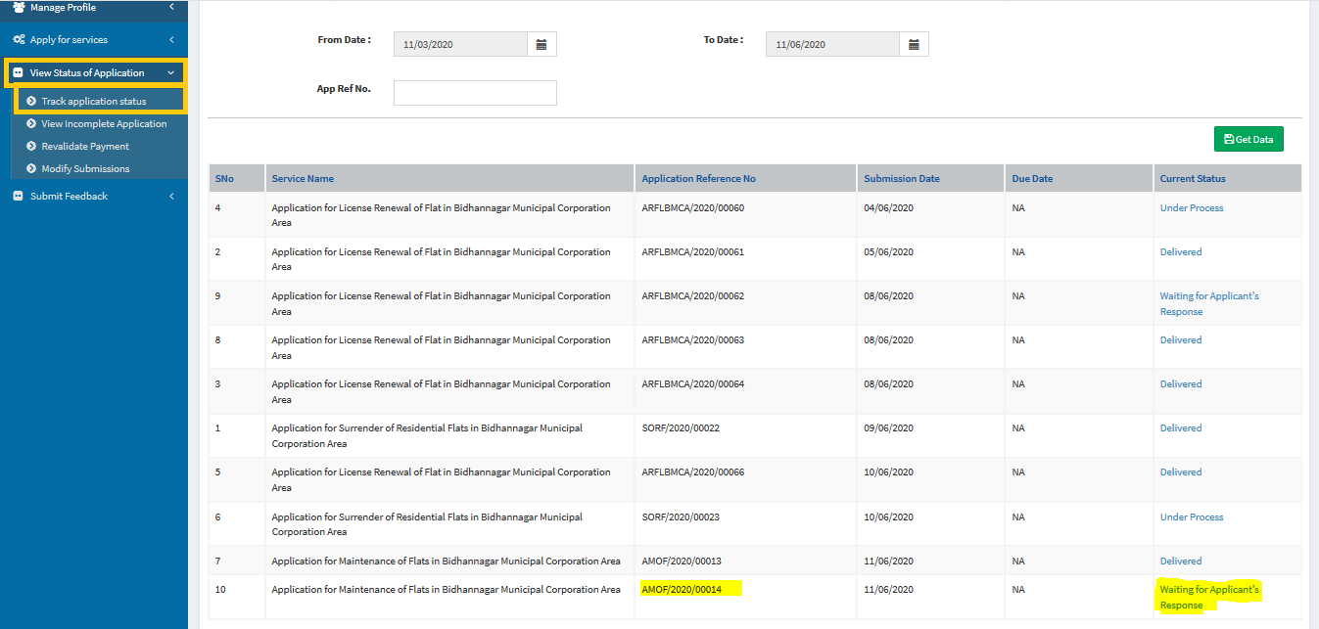

**Step -2:**

Select **click here** to re attach your attachment.

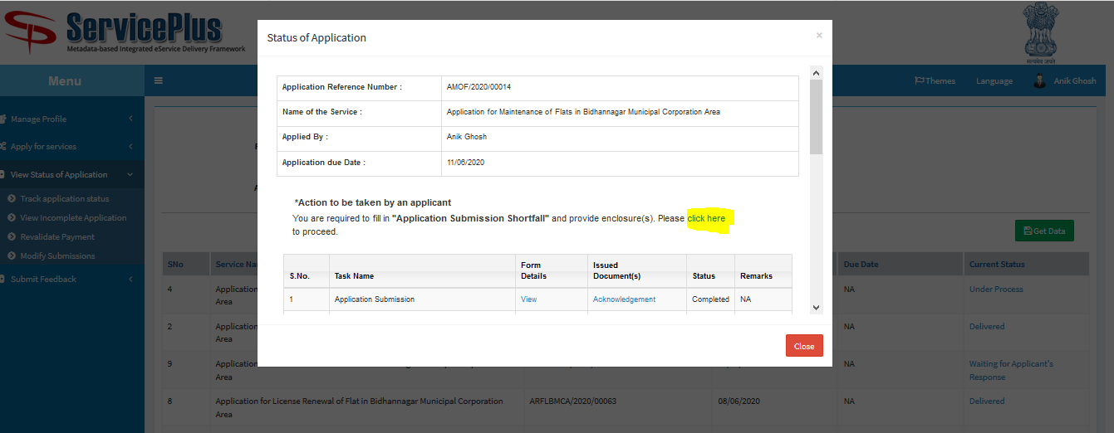

**Step -3:**

Give **Remarks** and click **submit.**

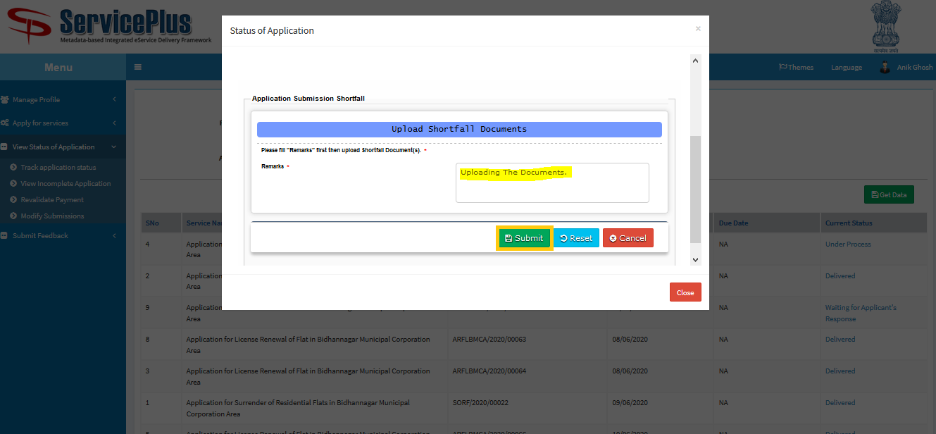

**Step -4:**

Attach the appropriate attachment and click **submit.**

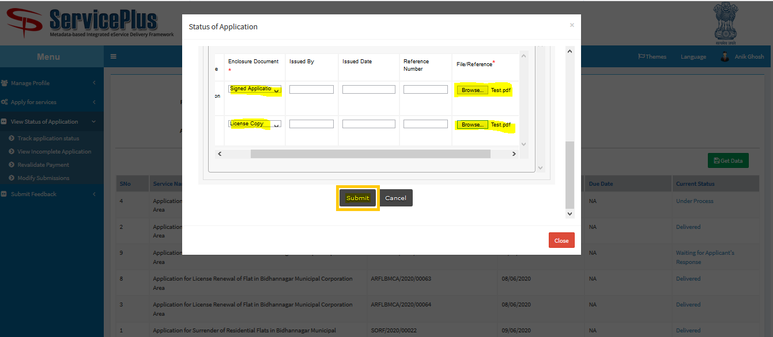

After Successful Submission this Message will be shown.

